SER-SW Chapter Board Meeting Agenda & Notes

November 30, 2017

Present:

# Introductions

# Current Roster

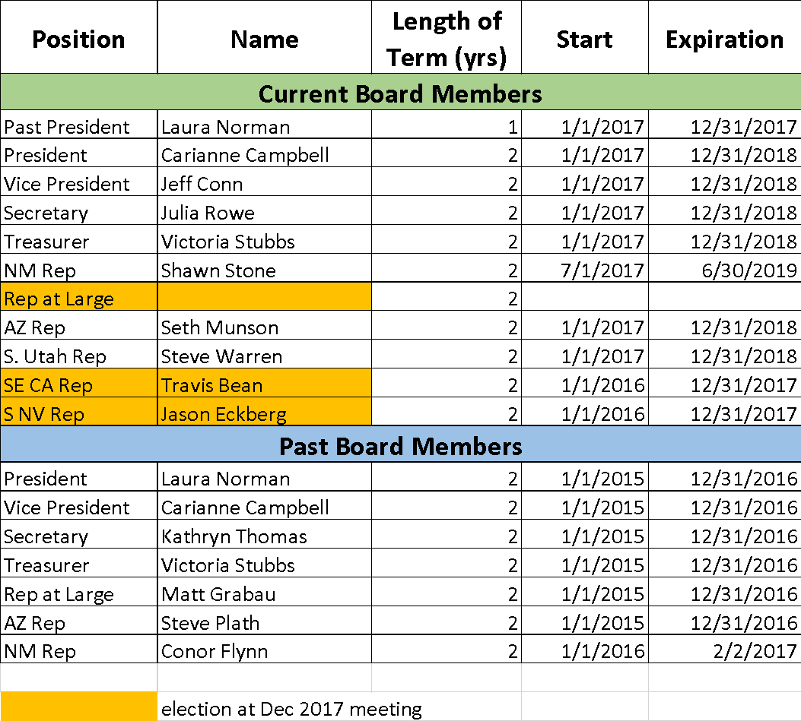

# Elections

* Email vote was sent to all current members 11/29/17
* No nominees accepted for S NV and SE CA
  + Do Travis and Jason want to stay on, or should we do further recruitment?
* Rep at Large will be announced at conference

# Budget Review: Vickie

# Conference Committee Update

* December 6 – 8 (Weds – Fri) in Albuquerque at: <http://www.hotelabq.com/?gclid=CIz11fzRp9ICFUpNfgodk6ME_A>
* 82 registrants so far, great program
* Who is coming??
* Will anyone have a laptop available for session?
* Could use some additional raffle prizes!

# Strategic Planning & Chapter Activities

* Survey sent, only 14 respondents
* Shawn to lead discussion at conference
* Social Media Update
  + We are up to 510 followers on Facebook, Thank you Shawn!
  + Corrie has set us up on Twitter
  + Placeholder: social media guidelines
* Recruitment
  + Letter to lapsed members Q1 2018

# Other Items?