SER-SW Chapter Board Meeting Agenda & Notes

October 4, 2017

Present:

# Introductions

# Current Roster

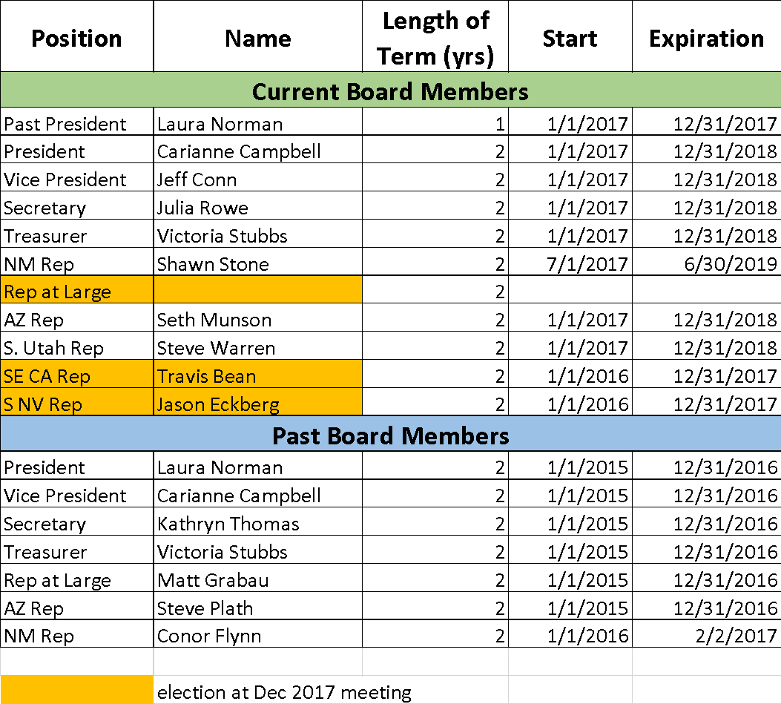

# Elections in December

* Representative At Large
* SE CA Rep
* S NV Rep
* Nominations request in next email
* Committee to handle nominations and election?

# Budget Review: Vickie

# Conference Committee Update

* December 6 – 8 (Weds – Fri) in Albuquerque at: <http://www.hotelabq.com/?gclid=CIz11fzRp9ICFUpNfgodk6ME_A>
* Conference intern, Corrie Navis!
* Call for abstracts is closed; Early bird Registration ends 10/31 at midnight
* Sponsors confirmed: MHR Accounting, Oxbow Ecological Engineering, Southern Nevada Water Authority, GeoSystems Analysis (check pending), Recon Environmental, SWCA, Sky Island Alliance (in kind)
  + Several more in the works
  + See google doc for tracking: <https://docs.google.com/spreadsheets/d/1Hvx7rKhs4tD37lLnCtVm3-KmX576e9Q0O2Rl_euyG5o/edit#gid=1530333563>
  + We could use more, please help! Here is the link to the sponsorship page for details: <http://sersw2017.wixsite.com/conference/sponsors-->

# Strategic Planning

* Need to send survey to membership
* Shawn

# Chapter Activities

* Social Media Update
  + We are up to 494 followers on Facebook, Thank you Shawn!
  + Corrie has set us up on Twitter and Instagram
  + Placeholder: social media guidelines
* Recruitment
  + Letter to lapsed members – Carianne to send with conference registration info by 9/1
* Website – Jason

# Next Email to Membership

* Nominations
* Amazon Smile announcement
* Membership Survey
* Send separate conference announcement to XWN list

# Other Items?