SER-SW Chapter Board Meeting Agenda & Notes

June 14, 2017

Present:

# Introductions

*In attendance: Vicki Stubbs, Travis Bean, Carianne Campbell, Julia Rowe, Shawn Stone, Seth Munson, and Jason Eckberg*

# Current Roster

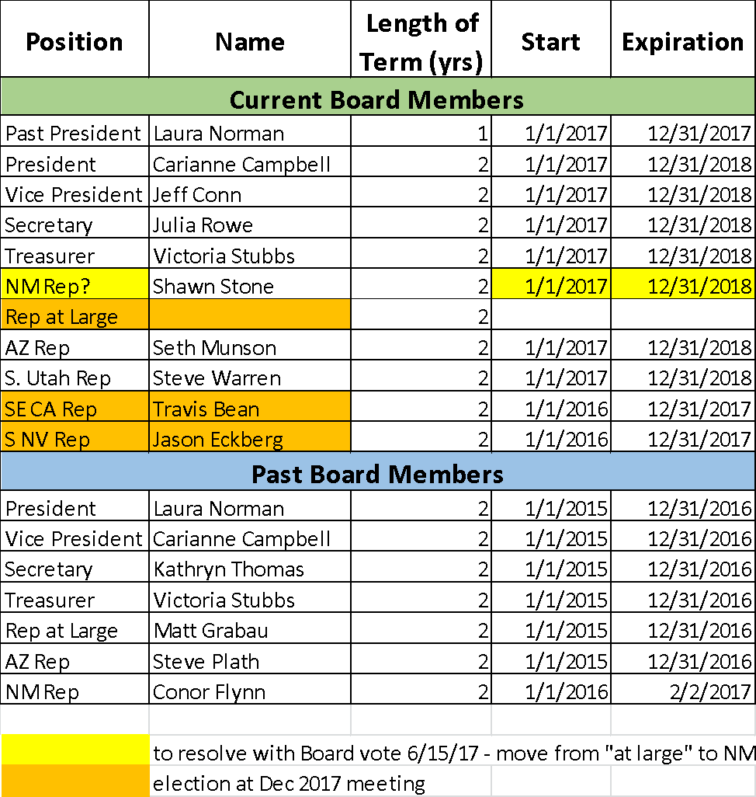

# NM Representative

* Vote to appoint Shawn Stone as NM Representative to replace Conor Flynn who resigned in Feb
* Representative At Large will then be open for Dec Election, along with SE CA and S NV

*We decided to send out an email to the board to vote on appointing Shawn Stone as the NM rep and then looking for an At Large representative. No one in attendance voiced any concerns about this move.*

# Budget Review: Vickie

* Update on Chapter payments: moving from quarterly (past) to semi-annual to annual
* Current Bank Balance: $12,026.21
* Expenses
  + Constant Contact renewed $178.20
  + Corporation Commission $10 annual fee (July)
  + Google Apps will be $12/month
  + Tamarisk Coalition - SERSW sponsored conference $500
* Vickie signed SERSW up for Amazon Smile, such that portions of an individuals Amazon purchase will be donated to their designated charity.  Someone designated SERSW and we rcvd $5.  :). Not really sure how to promote this, but thought I would remind us.
  + Add to e-news!
* Vickie will send a budget such that we can see the required financial obligations of the organization for the year as soon as email file transfer issues are resolved.
* We have **not** had to send Albuquerque a deposit yet.  That *could* mean they have accepted our credit request. :) Well done Jeff!
* We now have a google suite so that we can have email addresses that are csoley for SER business and that stay with the position, not the person i.e. president@SER.SW.org

# Cross-Watershed Network Annual Workshop

* Carianne attended and set up SER SW table
* Several email sign-ups and good exposure to practitioners
* We can send a special conference announcement to the list of attendees

# Conference Committee Update

* December 6 – 8 (Weds – Fri) in Albuquerque at: <http://www.hotelabq.com/?gclid=CIz11fzRp9ICFUpNfgodk6ME_A>
* Next committee meeting 6/26
* Vote on moving forward with a conference intern; we’d like to recruit from UNM to have a local on the ground intern
  + Julia will be drafting announcement
  + Shawn will be networking with UNM
* Shawn obtained conference email
* Call for **symposia/workshops to go out by end of June**
* *We have an offer from a contact at FB to sponsor a couple months of promotion – things we might like to highlight with that: hiring an intern, conference save the date/call for submissions*
* *SER is making it possible to pay for conference fees through the national SER site. What are the advantages and disadvantages of that? Costs?*

*7. Other News*

* *Seth – his organization now a coordinator Molly McCormick – building capacity and outreach*
  + *Colorado plateau conference – September tons of restoration – good venue for restoration in the southwest.*
  + *Has a paper in restoration ecology coming out next month.*
* *Shawn - Podcast! Interest in doing a podcast for SER – new literature for practitioners. Another step to help bridge the gap between researchers and practitioners. Could be a fun way to get information out*
* *Discussion of RAMPS database – want to be able to click on an area of interest and find out about projects going on the in the vicinity*

# Chapter Activities

* Member Survey
  + Shawn drafted questions with Carianne’s input – draft Survey Monkey to send to members
  + Give feedback on questions below!

#### **1. What state are you located in? (Choose one)**

Arizona



California



New Mexico



Nevada



Utah



Other (please specify)



#### **2. What is your role in restoration ecology? (Choose as many as apply)**

student



researcher



practitioner



land manager



Other (please specify)



#### **3. Why did you join the SW Chapter of SER?**



#### **4. Have you attended one of our annual conferences?**

2016 Las Vegas



2015 Tucson



2014 Alpine, TX



#### **5. Do you plan to attend our 2017 Annual Conference in Albuquerque December 6 - 8?**

yes



no



not sure



#### **6. As we develop our young chapter, which of the following services would be most desirable to you as a member, in addition to the annual meeting? (Choose up to 3)**

workshops



webinars



scholarships



field trips



networking



podcasts



Other (please specify)



#### **7. How would you like to interact with other SER members? (Choose all that apply)**

in person



webinars



social media



online searchable directory



I don't want to interact



Other (please specify)



#### **8. Would you be interested in serving on a planning committee with other members? If so, please describe your area of interest and include your email below.**



#### **9. Do you have any other ideas about how SER SW Chapter could be more useful to yourself or fellow members? Or do you have any other feedback you'd like to offer?**



* Social Media Update
  + We are up to 408 followers
  + Thank you Shawn
  + Placeholder: social media guidelines
* Recruitment
  + Letter to lapsed members – Carianne to send with conference registration info by 9/1
* Website – Jason
* Email newsletters – Carianne and Julia
  + May Newsletter: sent to 303 contacts, 48% open rate
  + June/July newsletter
    - Send newsy items, including job announcements!
    - Will include membership survey

# Next Meeting August 24th 12pm (AZ Time)

* Survey results
* Short-term strategic priorities
* Discuss formal strategic planning process

# Other Items?