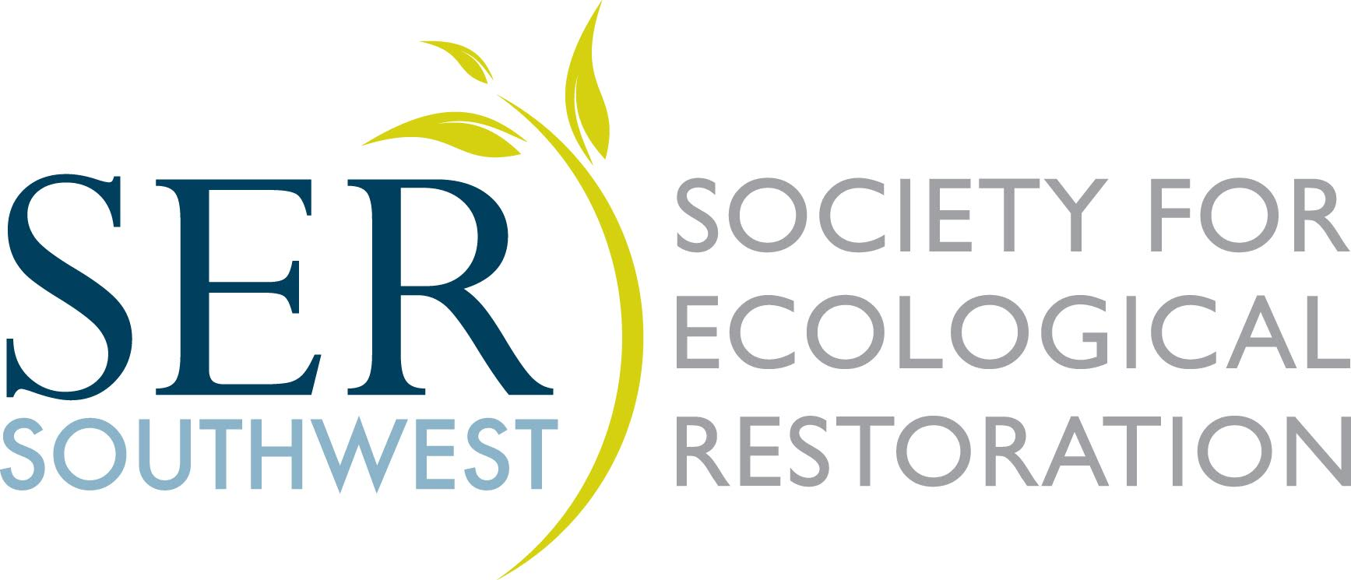SERSW 2018 Conference Scholarship Application

Personal Information
Name (First, Last): |  | School:

Street Address:

City, State, Zip code: |  | Phone Number:

E-mail address:

Important Information

Scholarships are available to students on a financial need basis; the number awarded will vary on sponsorships. Scholarships cover registration only; travel and accommodation expenses are the responsibility of the attendee; continental breakfast and lunch are provided each day. The scholarship winner is expected to participate in the conference administration experience by supporting vendor and registration activities, other small volunteer tasks, and will be able to attend all the sessions and the field day.

To apply for a scholarship, answer/explore the following (one page only) and email to ser.sw.conference@gmail.com.

ESSAY: Tell us about you. How do you currently improve and impact your community? How do you believe the SER Southwest Chapter Annual Conference will benefit you and your community? Express the nature of the financial challenge you face in attending this conference. Include unusual circumstances you believe merit special consideration, for example: financial hardship, disabilities, family responsibilities, etc.

Scholarship applications must be e-postmarked by August 15, 2018.

