Seed collection protocol (fall 2023)

Rubber Rabbitbrush (*Ericameria nauseosa*)

Goals: Collected seed of *E. nauseosa* will be used to establish common garden trials. These gardens will discern adaptive traits, role of phenotypic plasticity vs. local adaptation, ecological specialization, insect-plant co-evolution, and seed transfer.

Taxonomy: *Ericameria nauseosa* contains two subspecies: green (consimilis) and gray (nauseosa). Within subspecies there is a myriad of varieties.

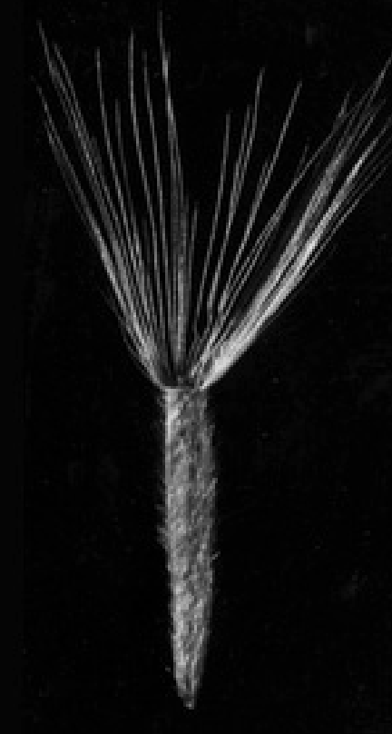

Figure . Rubber rabbitbrush achene with pappus. Achenes are about 5 mm in length. (Meyer 2008). Achenes should be fully formed (shown above) and easily dehiscent from the inflorescence.

Collection site strategy: Widespread varieties of E. nauseosa are our primary focus, although we will happily accept endemic varieties. Some of the varieties of interest include: hololueca, graveolens, speciosa, oreophila, and hybrids. Note: hybridization can be common in some areas making varietal determinations difficult to impossible. Determining the variety in the field is not necessary for seed collection, but for more information on the taxonomy please consult FNA: <http://floranorthamerica.org/Ericameria_nauseosa>

Sample Collection: Seed (Figure 1) should be collected at one locale (i.e., populations) approximately 1 -2 acres and one variety. Individual samples (i.e., seed collections from one plant) must be kept separated in paper bags. After checking and confirming a mature seed head (see Figure 2), clip at least a dozen inflorescences, 6 to 8 inches of stem (including leaves), and place them in an appropriately sized paper bag with inflorescence facing down. Label bags with collection site name that corresponds to the data sheet (next page). Bags can be folded and closed with staples to prevent seed mixing among samples. Repeat this process 15 times for separate plants (n = 15 samples for each population). Store collections in a cool dry place until shipment.

Timing: Flower phenology should be similar to big sagebrush. Colder sites (higher elevation and latitude) will flower first.

Desired Locations: If you are located near one or more of our previous collection sites, please consider collecting there. See the list of locations in Table 1, below.

Shipping: Ship samples within one or two days after collection. Ship at ambient temperature to the address below. Please notify me when the package has shipped (bryce.richardson2@usda.gov).

Note: Please dry wet samples from rain or dew before shipping.

Submit collections to:

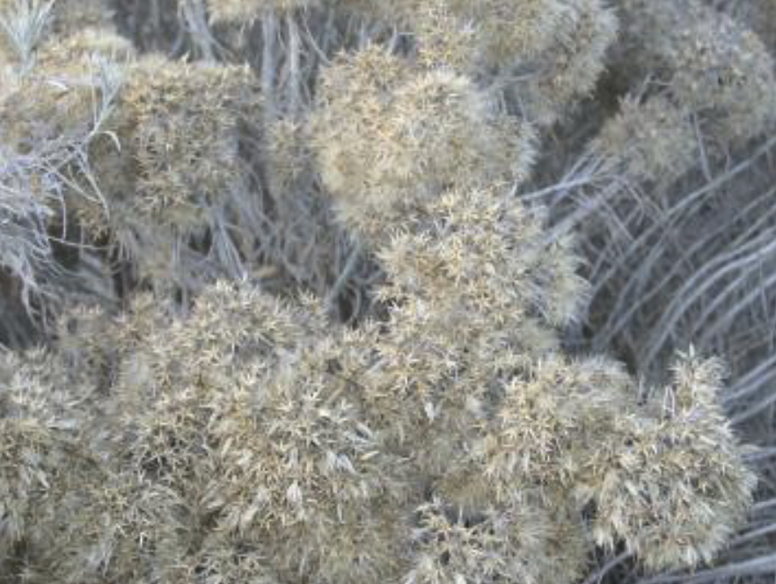

Figure . Inflorescences of ERNA. Mature seed heads are often tan to white. Immature seed heads remain yellow to dark brown (Love et al. 2014).

Bryce Richardson

USDA Forest Service

1221 South Main Street

Moscow, ID 83843

Phone: 208-883-2322

*If you would like paid shipping (UPS or FedEx) please let us know. (bryce.richardson2@usda.gov).

ERNA Collection data sheet

For each collection site record: site name, latitude, longitude, elevation, and append a site photo (see ERNA collection data sheet on the next page). These coordinates and elevation are important in analyses so accuracy matters. Also, record topographic and soil features listed in the data sheet. If other features of the site appear important, please attach other photos.

Thank you for your efforts!

ERNA collection data sheet

Collectors name:

Date of collection:

**Site description**

Site Name:

Latitude (decimal degrees):

Longitude (decimal degrees):

Elevation (meters):

Add location to the [google map](https://www.google.com/maps/d/edit?mid=1b43CMbCJbZUZ25nIMIKWBoUDcY3hm4w&usp=sharing). This will help with our planning.

**Associated insects or pollinators**

Galls (stem nodules)? Associated insects or pollinators? (E.g. grasshoppers, caterpillars, bees, syrphids). Leaf damage from herbivory? Please note and/or insert a photo:

Note any striking plant morphology?

Please describe or add photo:

**Site topography**

Estimated slope (%):

Aspect:

**Soil characteristics**

Link to [reference information](https://www.google.com/url?client=internal-element-cse&cx=002010345775656436459:wr5ari_h9jw&q=https://extension.usu.edu/utahnatureexplorers/files/generalnature/soilinvestigations/Soil-Investigations.pdf&sa=U&ved=2ahUKEwiXpsHukt-AAxUCNn0KHa8DAX0QFnoECAUQAQ&usg=AOvVaw2mkxGkhLgzXvnGf7hPYskE)

Soil texture (% clay, sand, silt):

Is this a roadside collection? (Is the collection comprised of plants that have colonized the road base):

**Site photos (add more if needed)**

Descriptions

Photo1:     , Photo 2:

Photo 3:     , Photo 4:

Table 1: Desired locations from previous genetic collections. [LINK](https://www.google.com/maps/d/edit?mid=1KknZ1tG407diRyVkJuu56E4pWYo98Oc&usp=sharing) to map.

|  |  |  |  |  |
| --- | --- | --- | --- | --- |
| Name | Lat | Long | State | Elevation |
| Austin Hwy | 39.600807 | -117.16 | NV | 1754 |
| Arenaria1 | 37.17384 | -112.61817 | UT | 1870 |
| Austin Summit | 39.473104 | -117.04945 | NV | 2408 |
| beaver canyon | 38.27982 | -112.56807 | UT | 1887 |
| Baker Hwy | 45.08907 | -117.84837 | OR | 1007 |
| OR badlands | 43.94395 | -121.02769 | OR | 1104 |
| Bald Mountain Canyon | 39.26398 | -117.7243 | NV | 2245 |
| bud 1 | 39.14467 | -111.75611 | UT | 1631 |
| bud 2 | 39.02786 | -111.74611 | UT | 1711 |
| Buena Vista | 43.0529 | -118.8715 | OR | 1277 |
| clover creek | 42.23095 | -122.08695 | OR | 1265 |
| CA4 | 38.07189 | 119.07318 | CA | 1983 |
| CA3 | 38.07189 | -119.07318 | CA | 1971 |
| city | 37.11173 | -113.56686 | UT | 888 |
| 10-6 cliff | 43.70761 | -118.51556 | OR | 1372 |
| corona | 41.94453 | -118.67245 | OR | 1257 |
| CA1 | 37.81108 | -118.5214 | CA | 1694 |
| CP3-69 | 37.04314 | -112.19856 | UT | 1647 |
| CA2 | 37.89452 | -118.85651 | CA | 2443 |
| CP3-70 | 37.76715 | -113.16933 | UT | 1758 |
| Diamond Crater | 43.075863 | -118.74855 | OR | 1295 |
| Dayton Hill | 39.211 | -119.60815 | NV | 1423 |
| 7-17-17 Death by Mosquito | 39.73112 | -111.15585 | UT | 2352 |
| 10-5 ditch | 43.43917 | -118.7375 | OR | 1240 |
| East Walker | 38.348308 | -119.21227 | CA | 2043 |
| Finger Rock | 38.570527 | -118.08163 | NV | 2129 |
| Grey's Butte | 42.9989 | -119.954 | OR | 1587 |
| Gallup Oreos | 35.50509 | -108.82932 | NM | 1977 |
| 7-17-17 hololeuca | 39.99726 | -111.31432 | UT | 1987 |
| Hwy 140 | 41.855409 | -118.57741 | NV | 1423 |
| HWY 138 | 34.32487 | -117.42191 | CA | 1125 |
| ID3 | 42.93847 | -115.0745 | ID | 936 |
| ID1 | 46.47515 | -116.76927 | ID | 242 |
| ID2 | 43.85619 | -116.22017 | ID | 1120 |
| Jones Canyon | 40.85155 | -119.56711 | NV | 1443 |
| Juncea1 | 36.9954 | -111.5949 | UT | 1249 |
| Juncea2 | 35.90452 | -111.54766 | AZ | 1504 |
| latisquamea | 35.20589 | -106.49663 | NM | 1906 |
| bigelovii1 | 35.03251 | -110.6452 | AZ | 1487 |
| lake road | 42.10784 | -119.74091 | OR | 1467 |
| bigelovii2 | 34.99441 | -107.30143 | NM | 815 |
| Long Valley | 39.625991 | -120.01047 | CA | 1668 |
| Muddy Creek Rd | 45.9991 | -110.833 | MT | 1660 |
| Modoc | 41.41059 | -120.54402 | CA | 1333 |
| Blacks Ford/Madison River | 45.99906 | -110.83305 | MT | 1663 |
| 80-highway | 41.07343 | -115.29237 | NV | 1633 |
| NV3 | 38.02388 | -117.86911 | NV | 1440 |
| Nitida1 | 35.95807 | -111.76713 | AZ | 1935 |
| NV1 | 39.22624 | -114.90315 | NV | 2035 |
| NVII-1 | 39.4813 | -117.01531 | NV | 2148 |
| NV2 | 38.1679 | -116.43906 | NV | 1910 |
| NVII-2 | 40.59495 | -116.17294 | NV | 1476 |
| not bud 1 | 38.57794 | -112.33389 | UT | 1789 |
| not bud 2 | 38.71723 | -112.3746 | UT | 1914 |
| 10-2 paintbrush | 43.93003 | -121.10583 | OR | 1200 |
| Peavine Low 2 | 39.6065 | -119.8993 | NV | 1724 |
| Patagonia | 39.5048 | -119.9022 | NV | 1421 |
| Petrified Wash | 38.5949 | -118.11525 | NV | 1859 |
| OR3 | 45.72944 | -119.04667 | OR | 318 |
| 10-4 rollover | 43.52944 | -119.29861 | OR | 1390 |
| OR1 | 44.14689 | -117.10694 | OR | 881 |
| rest stop green | 37.51538 | -113.2111 | UT | 1628 |
| OR2 | 45.3445 | -118.22667 | OR | 883 |
| Smith Creek (aka Desatoya) | 39.38344 | -117.62386 | NV | 1990 |
| sea hwy | 41.32371 | -117.70572 | NV | 1487 |
| Snake John Wash | 40.237306 | -109.08544 | UT | 1727 |
| Speed Limit 19 | 35.21852 | -111.64226 | AZ | 2140 |
| Spanish Springs | 40.73664 | -120.31685 | CA | 1647 |
| toquerville | 37.28252 | -113.30629 | UT | 1159 |
| tunnel | 37.22645 | -113.37766 | UT | 1004 |
| Unknown 1 | 37.11617 | -111.97725 | UT | 1447 |
| UT1 | 39.08505 | -113.50959 | UT | 1438 |
| UT2 | 39.07335 | -113.71999 | UT | 1671 |
| Victorville-ish | 34.59045 | -117.25938 | CA | 869 |
| Virginia Mountains | 39.91538 | -119.90043 | NV | 1503 |
| 10-7 wash | 43.82544 | -117.64056 | OR | 762 |
| 10-3 yellow | 43.53928 | -119.43722 | OR | 1307 |